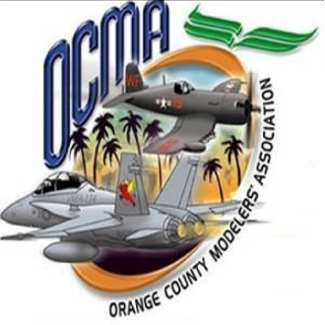
ORANGE COUNTY MODELERS ASSOCIATION
BOB SWENSON FLYING SITE APPLICATION

New _____ Renewal _____ Membership Badge Number ______________

Name: _______________________________________________ AMA# _________________ Verified _______
Last, First Initial

Address: _____________________________________________ City: __________________________________

State: __________ Zip: _______________ Email: __________________________________________________

Home Phone: ___________________________________ Cell Phone: ___________________________________

_______________________________________________ ____________________________________________
Participating Club Affiliation Model Interest

Annual Membership: ______$100.00____
New Member Initiation Fee: ______$ 50.00____ Amount Paid: ____________________________
Cash / Check

Make check payable to OCMA and mail to: Orange County Modelers Association
Include copy of 2013 AMA card with application Attn: Greg Stone
P.O. Box 7750
Laguna Niguel, CA 92607

Email a passport size, current photo of yourself to gstone4@cox.net when you submit your application.

An OCMA membership badge will be issued in your name permitting you to fly at the OCMA Flying Site. When flying at Bob Swenson Field you must have your OCMA Membership Badge & current AMA Card with you. Your OCMA Membership Badge must be worn in plain sight at all times.
When flying, if using non-2.4Ghz equipment, attach your OCMA Membership Badge to the frequency board, in place of the pin when using that frequency.
I further understand and accept that a Field Marshall may suspend my OCMA Membership Badge for Safety and OCMA Flying Site Rule Violations.
By signing this form you acknowledge understanding and agreement to comply with OCMA and AMA rules. Upon non-renewal or cancellation of membership, gate access key must be returned to OCMA.

___________________________________________________ _____________________________________
Member Signature Date

